**TRINITY INTERNATIONAL SS & COLLEGE**

**Dillibazar Height, Kathmandu, Nepal**



**LAB WORK # 5: Application Package (MS-Excel)**

**(COMPUTER SCIENCE)**

**SUBMITTED BY: SUBMITTED TO:**

**NAME: Prashim Timsina**

**GRADE: XI (MC1)**

**DATE : [2079/08/23] PRAVEEN KOIRALA**

**Faculty of Computer Science**

**KATHMANDU, NEPAL**

**2022 Table of Contents**

S. No. Page No.

1. Acknowledgement I

2. Objectives II

3. Table of Contents III

4. Theoretical Background (1)

4.1 Application Package

4.1.1 Relative, Absolute and Mixed cell reference

4.1.2 PivotTable

4.1.3 Charts, and Graph

5. Work Done

5.1 Cell reference 2

5.2 PivotTable 2

5.3 Graphical Analysis 3

6. Conclusion

7. Bibliography

8. Appendix

**2. Objective**

The main objectives of the lab work are as follows:

1. To understand and apply Relative, Absolute and Mixed cell reference.
2. To understand and create a Pivot Table to analyze data in excel.
3. To represent data graphically using charts.

**3. Theoretical Background**

Relative cell reference: Relative cell reference is a type of cell reference where no dollar is used. For e.g. A1

Absolute cell reference: Absolute cell reference is a type of cell reference where dollar sign is used to trigger both the row and column. For e.g. $A$1

Mixed cell reference: Mixed cell reference is a type of cell reference where dollar sign is used to trigger either row or column. For e.g. $A1, A$1

PivotTable: A pivot table is a statistics tool that summarizes and reorganizes selected columns and rows of data in a spreadsheet or database table to obtain a desired report.

Graphs: Graphs and charts are those pictorial representation that represent a statistical data in a well organized and understandable format.

Page: 1

**4. Work Done**

1) Cell Reference

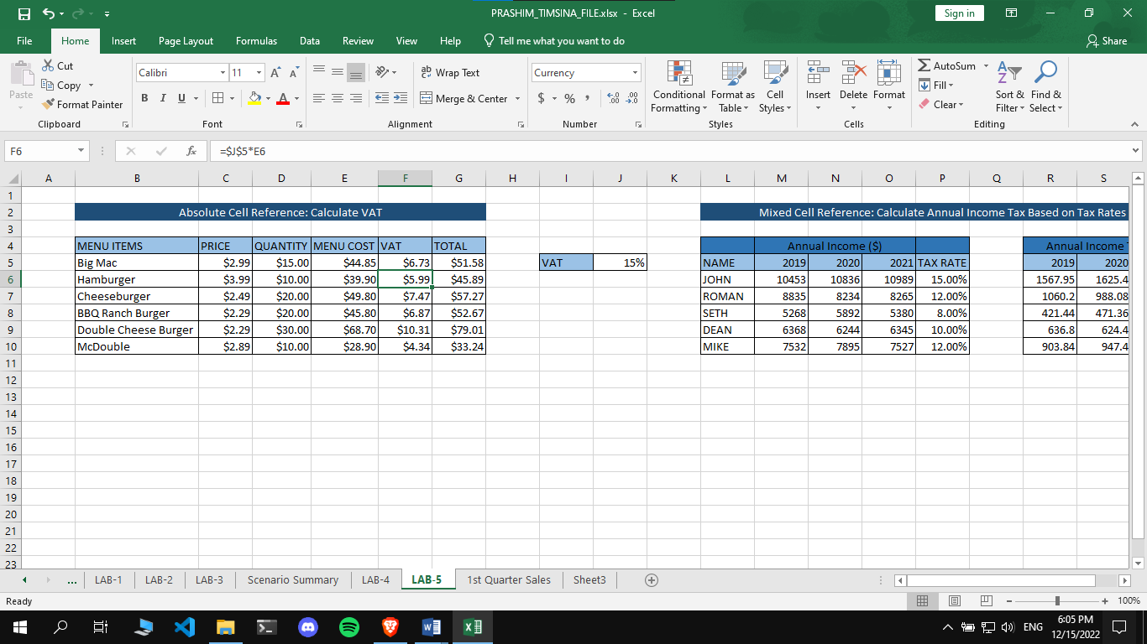

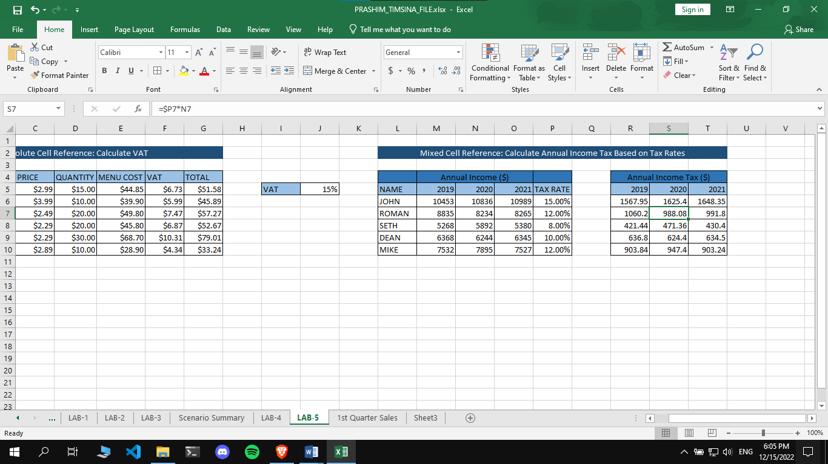

Page: 2

2) PivotTable

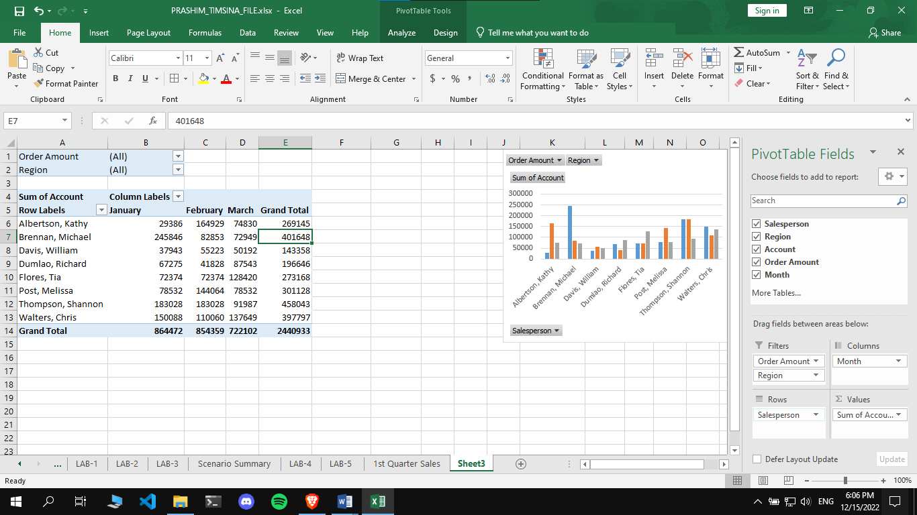

3) Graphical Analysis

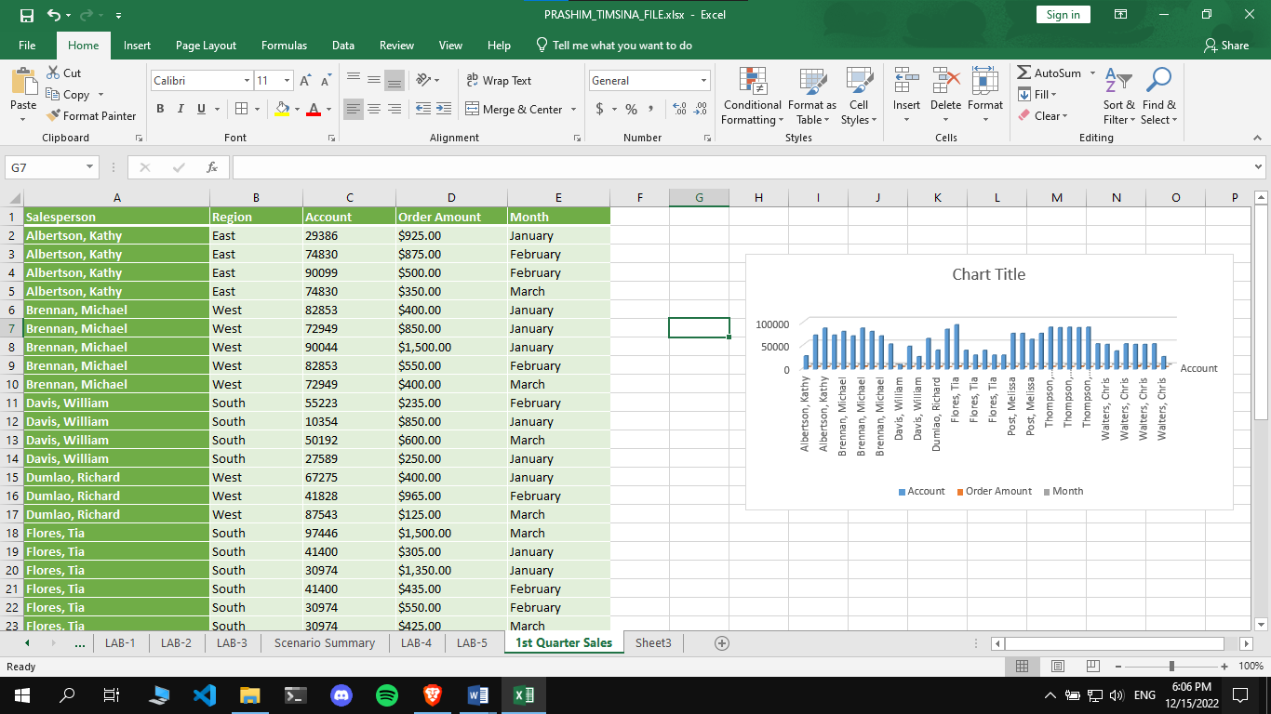

Page: 3

Page: 3

Page: 4